Level 0.

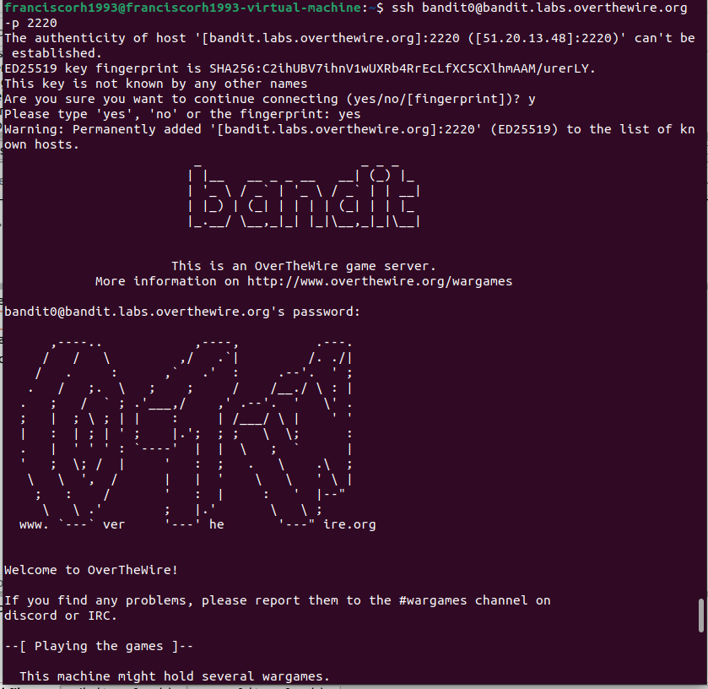

Level 1.

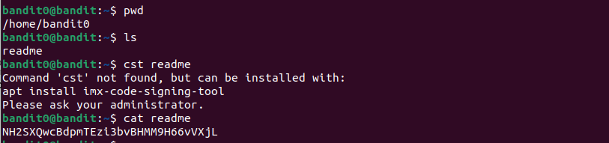

Level 2.

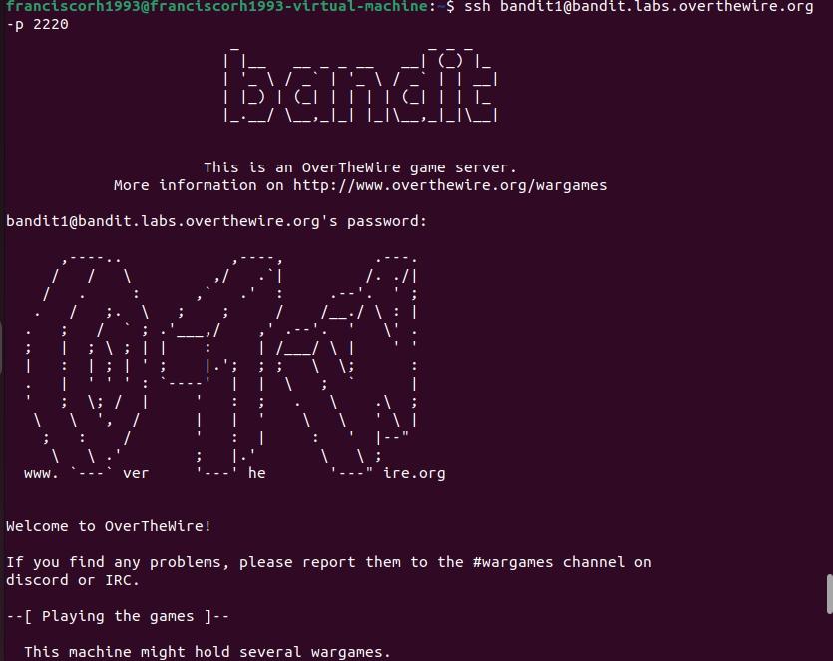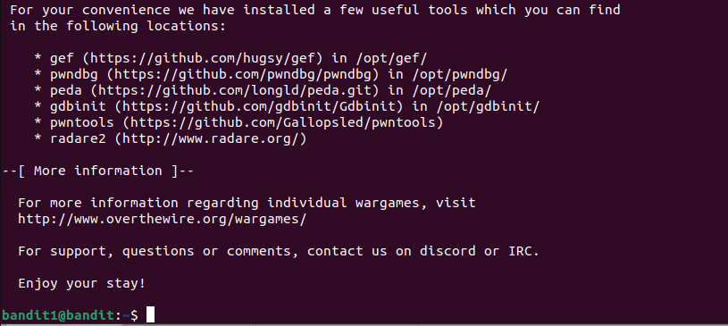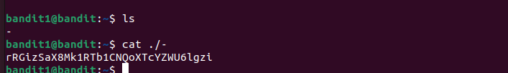rRGizSaX8Mk1RTb1CNQoXTcYZWU6lgzi

Level 3.

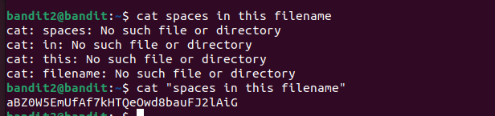aBZ0W5EmUfAf7kHTQeOwd8bauFJ2lAiGCD

Level 4.

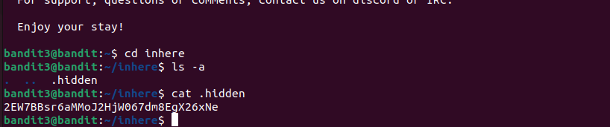2EW7BBsr6aMMoJ2HjW067dm8EgX26xNe

Level 5.

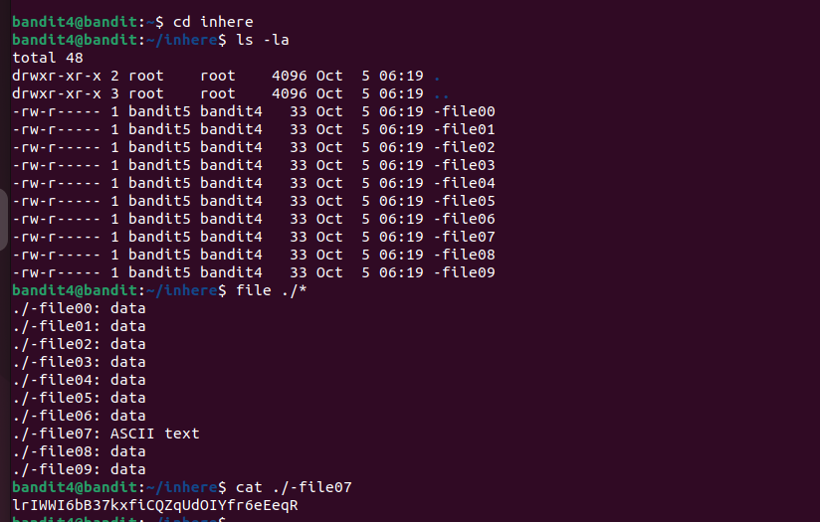lrIWWI6bB37kxfiCQZqUdOIYfr6eEeqR

Level 6.

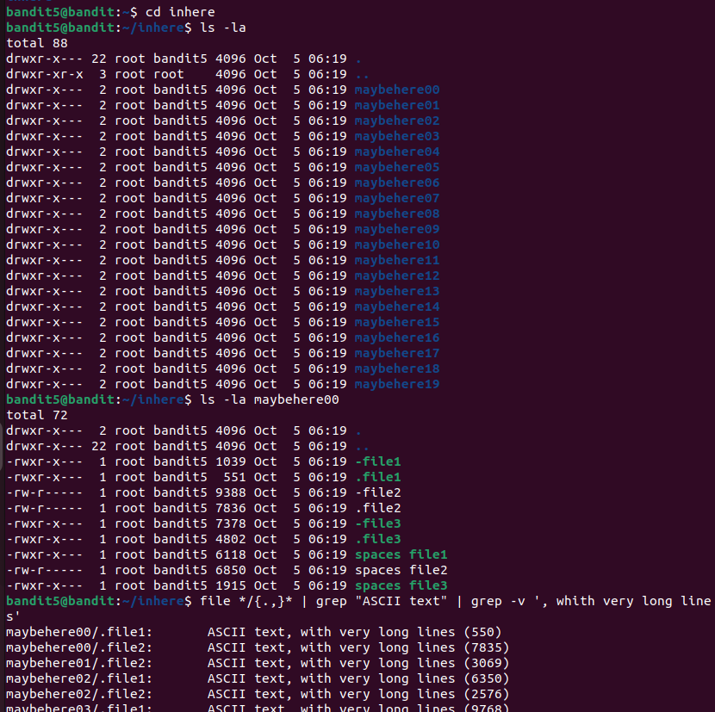P4L4vucdmLnm8I7Vl7jG1ApGSfjYKqJU

Level 7.

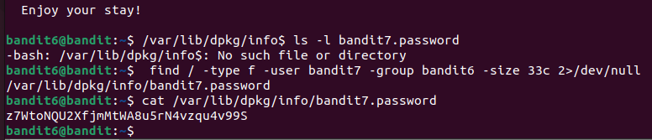z7WtoNQU2XfjmMtWA8u5rN4vzqu4v99S

Level 8.

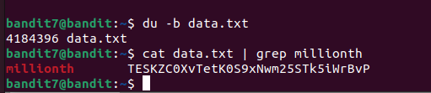

TESKZC0XvTetK0S9xNwm25STk5iWrBvP

Level 9.

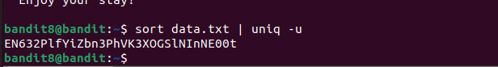EN632PlfYiZbn3PhVK3XOGSlNInNE00t

Level 10.

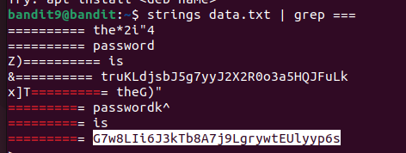

G7w8LIi6J3kTb8A7j9LgrywtEUlyyp6s

Level 11.

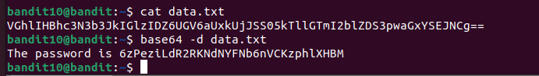6zPeziLdR2RKNdNYFNb6nVCKzphlXHBM

Level 12.



JVNBBFSmZwKKOP0XbFXOoW8chDz5yVRv

Level 13.

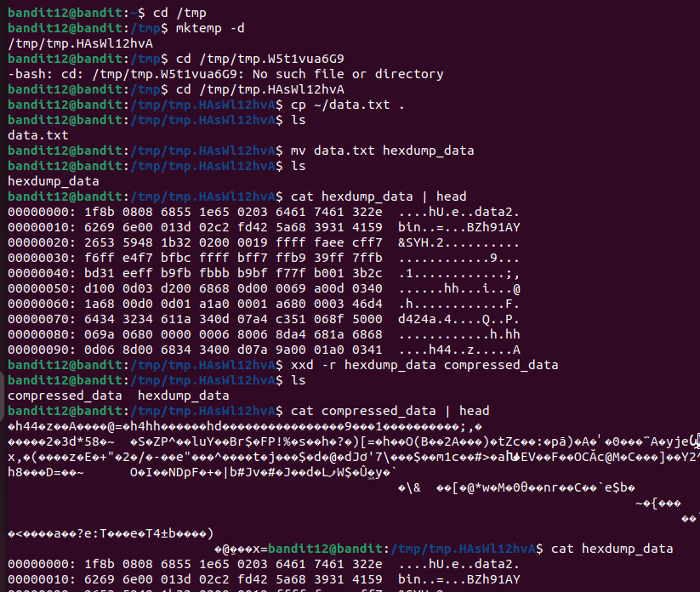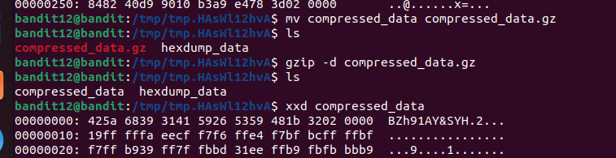wbWdlBxEir4CaE8LaPhauuOo6pwRmrDw

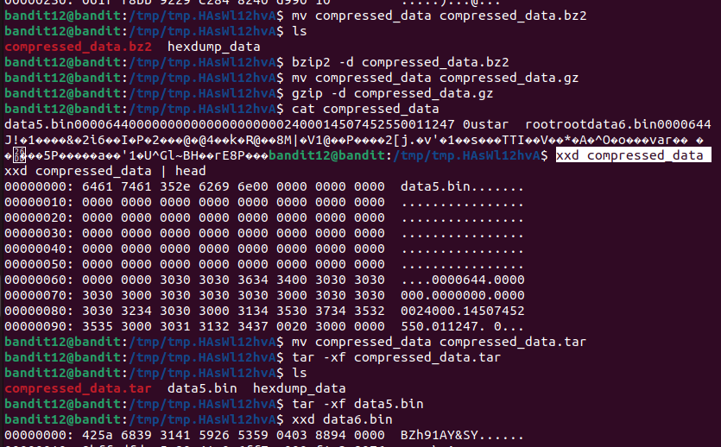

Level 14.

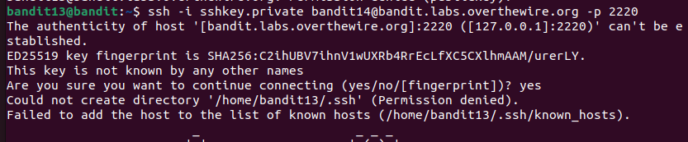

C2ihUBV7ihnV1wUXRb4RrEcLfXC5CXlhmAAM/urerLY.

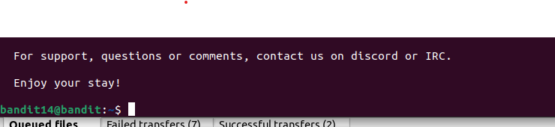

Level 15.

FGrHPx402xGC7U7rXKDaxiWFTOiF0ENq

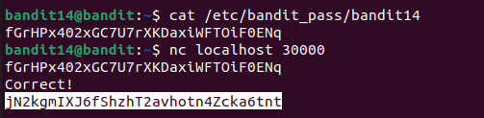

jN2kgmIXJ6fShzhT2avhotn4Zcka6tnt

Level 16.

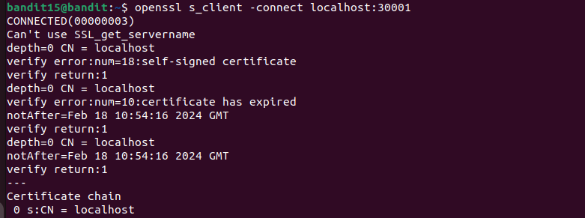

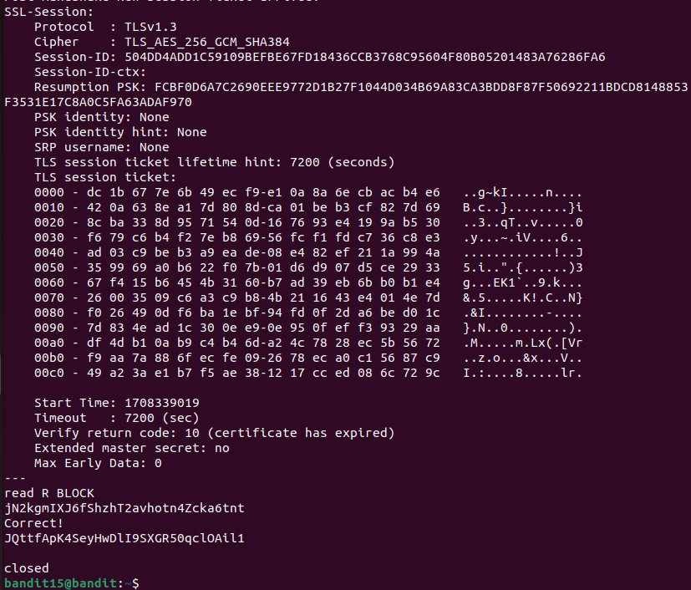JQttfApK4SeyHwDlI9SXGR50qclOAil1

Level 17.

Level 18.

Level 19.

Level 20.

Level 21.

Level 22.

Level 23.

Level 24.

Level 25.

Level 26.

Level 27.

Level 28.

Level 29.

Level 30.

Level 31.

Level 32.

Level 33.